Held at Piedmont Gun Club, Rutherfordton, N.C.
Fees: National Tournament (100 & 200-yard events) plus a practice day on Friday is $120.
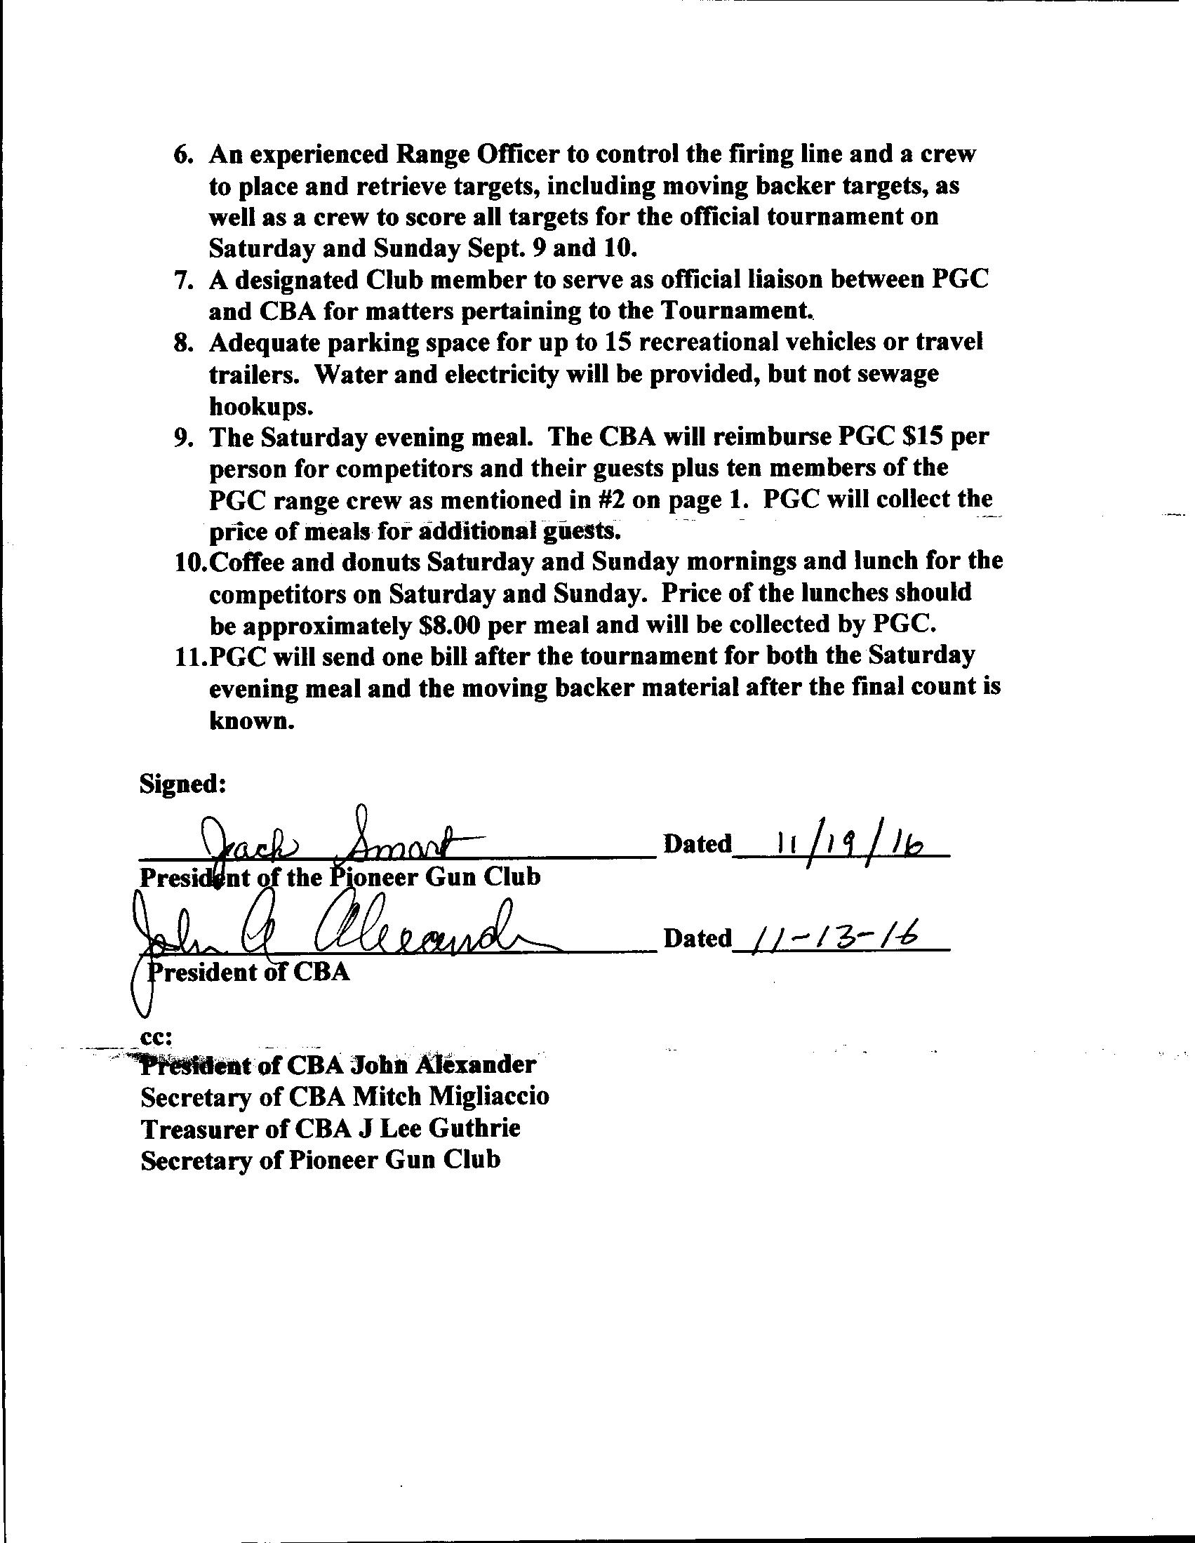
Total Fee for entering two guns is $240
Deadline for applications is: August 20th, 2024
Entry early and plan your year
Entries accepted to Range Capacity

Additional 100 yard matches on Friday:
Offhand Match is $10 fee
Quarter-Bore Match is $10 fee
Little-Bore Match is $10 fee

Catered Dinner: Saturday Night Dinner is $16 per person
Mail Entry Form and Fees to: Edward B. Camp, 8016 Wayne Ave., Kansas City, MO 64131
Entry Information:
I will be shooting the Two-Day Tournament: Yes: No: Fee: $ __________
I will be registering Two firearms in the Tournament: Yes: No: Fee: $ __________
I will be shooting the Quarter-Bore Match: Yes: No: Fee: $ __________
I will be shooting the Little-Bore Match: Yes: No: Fee: $ __________
I will be shooting the Offhand Match: Yes: No: Fee: $ __________
I will require Dinner Reservations for Saturday for ____ persons at $16 each: Fee: $ __________
Make check or money order payable to: Total fees included $ __________
The Cast Bullet Association, Inc.
Match is limited to 40 shooters.
Bench rotation on Sun. Note: No change of class after entry without approval of Match Director
Personal Information (required): Please PRINT Clearly Left-Hand Shooter?
I will be shooting in the ___________________________Class. Caliber: ______________
I understand that the improper use of firearms entails risk of bodily injury or property damage, and that neither the Cast Bullet Association, Inc. nor the Piedmont Gun Club, Inc. will be able to exercise complete control at all times of all entrants or attendees at the event described above, nor will they be able to ensure the complete safety of equipment or ammunition. I therefore relieve the Cast Bullet Association, Inc. and the Piedmont Gun Club, Inc. of any and all responsibility for injuries or damages which I, or any member of my party, may sustain as a result of my participation and/or presence at the National Tournament.

Name (print)_________________________________ Signature_________________________________
Street Address_________________________________________________________________________
City________________________________________________________State:_______ Zip___________
Telephone_________________________Email_______________________________________________
Grand National Championship Trophy: The Grand National Championship Trophy will be awarded for the highest standings based on 120 record shots fired for group and score, with 60 shots at 100 yards and 60 shots at 200 yards. In order to be eligible, each rifle or pistol class must have a minimum of 10% of the total number of entrants. Points will not be awarded in the Quarter-Bore, Little-Bore or Off-Hand Matches.

