The Forty-Third National Tournament
Held at Pioneer Gun Club, Kansas City, MO - September 6TH through September 8TH
Fees: Complete tournament (100 & 200-yard events) plus a practice day on Friday is $100.
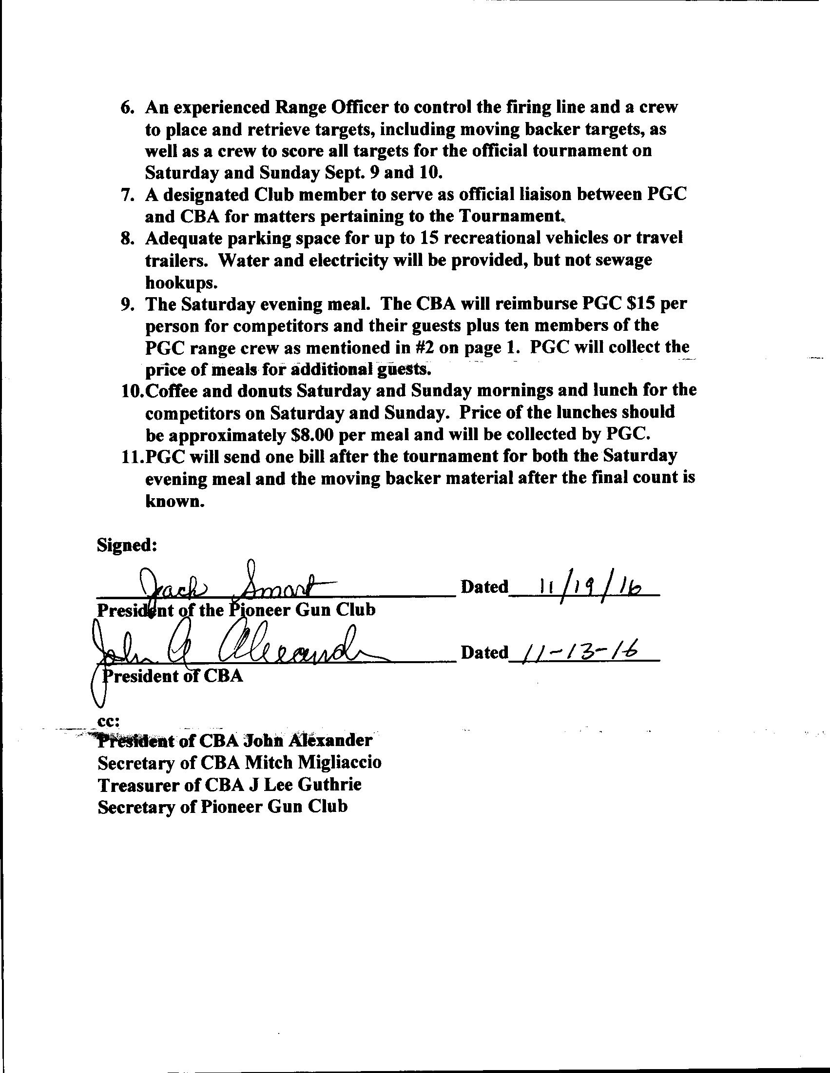
Either Saturday or Sunday only is $50 Offhand Match on Friday is $10
The fee for shooting two guns is $200. Quarter-Bore Match on Friday is $10.
If competing with two firearms specify which one you are shooting for the Grand Championship at time of sign-in registration
Little-Bore Match on Friday is $10
Dinner: Saturday Night Dinner is $16 per person

Applications received after August 30th subject to a $20 late fee. Preference is given to single firearm entrants and those registering for both days.

Deadline for applications is August 30th, 2019
*Applications postmarked by August 1st will be entered
in an Early Bird drawing for a $100 cash prize*
Mail Entry Form and Fees to: Edward B. Camp, 8016 Wayne Ave., Kansas City, MO 64131
Entry Information:
I will be shooting the Two-Day Tournament: Yes: No: Fee: $ __________
I will be registering Two firearms in the Tournament: Yes: No: Fee: $ __________
I will be shooting the Quarter-Bore Match: Yes: No: Fee: $ __________
I will be shooting the Little-Bore Match: Yes: No: Fee: $ __________
I will be shooting the Offhand Match: Yes: No: Fee: $ __________
I will require Dinner Reservations for Saturday for ____ persons at $16 each: Fee: $ __________
I am paying a late Fee of $20 (added to total fees): Yes: No: Fee: $ __________
Make check or money order payable to: Total fees included $ __________ The Cast Bullet Association, Inc.
Match is limited to 56 shooters. Bench rotation on Sun. Note: No change of class after Aug. 30th without OK of Match Director
Personal Information (required): PLEASE PRINT CLEARLY
I will be shooting in the _____________________Class. Caliber: _______ Left-Hand Shooter
I understand that the improper use of firearms entails risk of bodily injury or property damage, and that neither the Cast Bullet Association, Inc. nor the Pioneer Gun Club, MO. will be able to exercise complete control at all times of all entrants or attendees at the event described above, nor will they be able to ensure the complete safety of equipment or ammunition. I therefore relieve the Cast Bullet Association, Inc. and the Pioneer Gun Club, MO. of any and all responsibility for injuries or damages which I, or any member of my party, may sustain as a result of my participation and/or presence at the National Tournament.

Name (print)_________________________________ Signature_________________________________
Street Address_______________________________________
City and State_______________________________________ Zip___________
Telephone_________________________Email_______________________________________________
Grand National Championship Trophy
The Grand National Championship Trophy will be awarded for the highest standings based on 120 record shots fired for group and score, with 60 shots at 100 yards and 60 shots at 200 yards. Points will not be awarded in the Quarter-Bore, Little-Bore or Off-Hand Matches. In order to be eligible, each rifle or pistol class must have a minimum of 10% of the total number of entrants.

